1. Write a Python Program to Check if a Number is Positive, Negative or Zero?

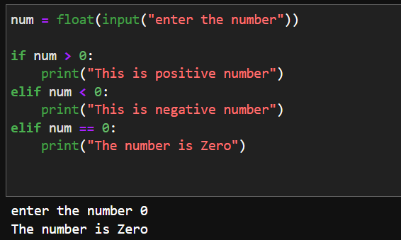

2. Write a Python Program to Check if a Number is Odd or Even?

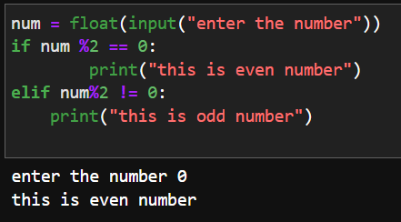

3. Write a Python Program to Check Leap Year?

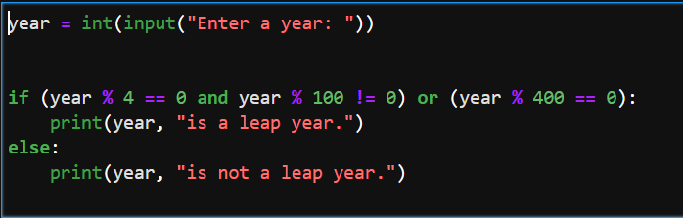

4. Write a Python Program to Check Prime Number?

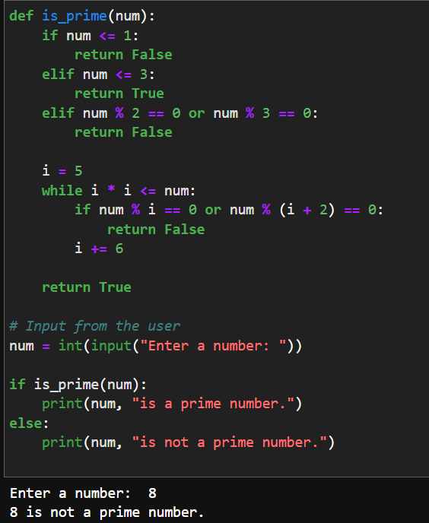

5. Write a Python Program to Print all Prime Numbers in an Interval of 1-10000?

